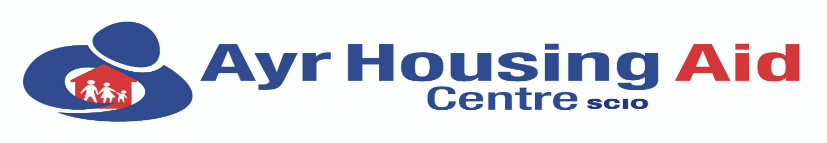
South Ayrshire Independent Housing Information, Advice, Advocacy and Engagement Services

7 York Street, Ayr KA8 8AN Website: www.ayrhousingaidcentre.com
Tel: (01292) 288111 E-mail: info@ayrhousingaidcentre.com
Text & WhatsApp Advice: 07549 603895 Chief Executive Officer: Suzanne Slavin BSc (Open)

SELF DECLARATION FORM (Enhanced level)

Private and Confidential

The post that you have applied for is for a prescribed purpose and is therefore exempt from the Rehabilitation of Prisoners Act 1974. You are therefore required to disclose all convictions (spent and unspent), cautions, and any relevant non-conviction information.

Please give details regarding any convictions and cautions under the heading in Section 1.

Please give details of any relevant non-conviction information in Section 2.

If you have no convictions, cautions, or relevant non-conviction information please go to Section 3 and sign the Declaration Form.

Section 1

a) Please give the date and details of the conviction(s) that you were charged with, the sentence that you received and the court where your conviction(s) was heard.

b) Please give details of the reasons and circumstances that lead to your offence(s).

c) Please give details of how you completed the sentence imposed, (for example did you pay your fine as required, what conditions were attached to your probation/community service/supervised attendance order, did you comply with the requirements of your order/custodial sentence etc.

d) Have any other organisations supported you to work through any of the above issues?

e) What have you learned from the experience?

Section 2

Non-conviction relevant information e.g. are there any ongoing investigations or complaints which could impact on your employment?

Section 3

Declaration (I certify that all information contained in this form is true and correct to the best of my knowledge and realise that false information or omissions may lead to dismissal).

Signature: _______________________________ Date: _____________________

PLEASE RETURN:- Application, Equal Opportunities Monitoring and Self Declaration forms to:- management@ayrhousingaidcentre.com

The information you give us in this form will be treated in the strictest confidence and
complies with our GPDR and data protection policy and procedures.

