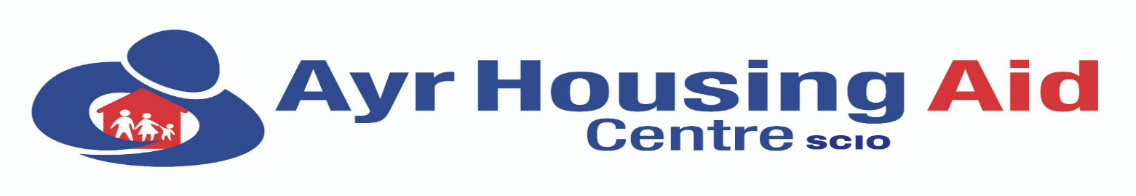
South Ayrshire Independent Housing Information, Advice, Advocacy and Engagement Services

7 York Street, Ayr KA8 8AN Website: www.ayrhousingaidcentre.com
Tel: (01292) 288111 E-mail: info@ayrhousingaidcentre.com
Text & WhatsApp Advice: 07549 603895 Chief Executive Officer: Suzanne Slavin BSc (Open)

EQUAL OPPORTUNITIES MONITORING FORM

Ayr Housing Aid Centre SCIO operates an Equal Opportunities recruitment and selection policy which ensures that no job applicant or employee is treated less favourably than any other. For the policy to be effective, detailed monitoring of applications requires to be carried out to ensure that no candidate is discriminated against on the grounds of gender, race, colour, nationality, ethnic or national origins, marital status, disability, sexuality or age.

We appreciate information provided which will be treated in the strictest confidence and will be used simply to provide a statistical profile of applicants. Thank you for your co-operation.

PLEASE TICK THE APPROPRIATE BOX
SEX  Are You?  Male  Female  Other  ______________________________  MARITAL STATUS  Are You?  Married  Not Married  Other | ETHNIC ORIGIN  Are You?  White  Black – African  Black – Caribbean  Black – Other  (please specify)  ……………………………………….  Indian  Bangladeshi  Pakistani  Chinese  Other  (please specify)  ………………………………………. | AGE  Are You?  Aged Under 21 years  21 – 30  31 – 40  41 – 50  51 – 60  Over 60  ________________________________  DISABILITY  Are You?  Registered Disabled  Disabled  (not Registered)  Not Disabled

POST APPLIED FOR :

PLEASE RETURN:- 3 Forms – (Application, Equal Opportunities Monitoring and Self Declaration) to:-management@ayrhousingaidcentre.com The information you give us in this form will be treated in the strictest confidence and complies with our GPDR and Data Protection policy and procedures.

