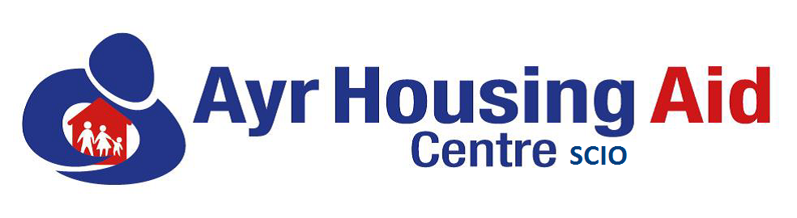

TRUSTEE ROLE DESCRIPTION

POST: Trustee of the Centre

GRADE: Volunteer

RESPONSIBLE TO: Board of Trustees

PURPOSE:

The Trustee will provide direction for the Centre on a wide range of matters with due care and diligence. They will provide strategic overview in terms of purpose and delivery of services. They will develop forwarding planning systems which consider current and future factors which impact on services we provide. They will closely monitor and review external and internal factors which influence the need for services within South Ayrshire.

Accountability
The Trustee is accountable to the Board, contractual partners, regulatory bodies such as OSCR and Care Inspectorate.
Trustee’s manage the Centre effectively and regularly meet to oversee the activities and services provided by the Centre. They have a vital role in terms of setting and reviewing policies and procedures in consultation with all staff within the Centre and if appropriate partner agencies.
The Committee shall ensure that our Annual Report is completed, and our AGM is held within the timescales set out within the Constitution of the Centre.

Interest of the Charity

Trustees are expected to put the interest of the charity before their own interests or the interests of any other person or organisation. Applicants must be committed to the ethos/aims and objectives of the Centre.

Charitable Purpose

Trustee much ensure the charity is operating and fulfilling its charitable purpose as outlined within its constitution.
Specific duties

- Attend Board Meetings and Sub-Committee meeting as required

- Give priority to the interests of the Centre

- Act with due care and diligence

- Ensure the charity operates within its charitable purpose

Qualifications and Skills

- Experience within the Charitable Sector
- Understanding of decision-making systems within Local and National Government
- Good understanding in terms of housing and homelessness
- Good understanding Debt, Benefits and income maximisation
- Understanding poverty related issues
- Good team worker
- Attendance at related training and seminars

Personal Qualities

- Maturity
- Patience
- Excellent interpersonal skills
- Confident
- Caring and approachable
- Resourceful
- Negotiating ability
- Non-judgemental

